**Year 11 Parent Information Evening**

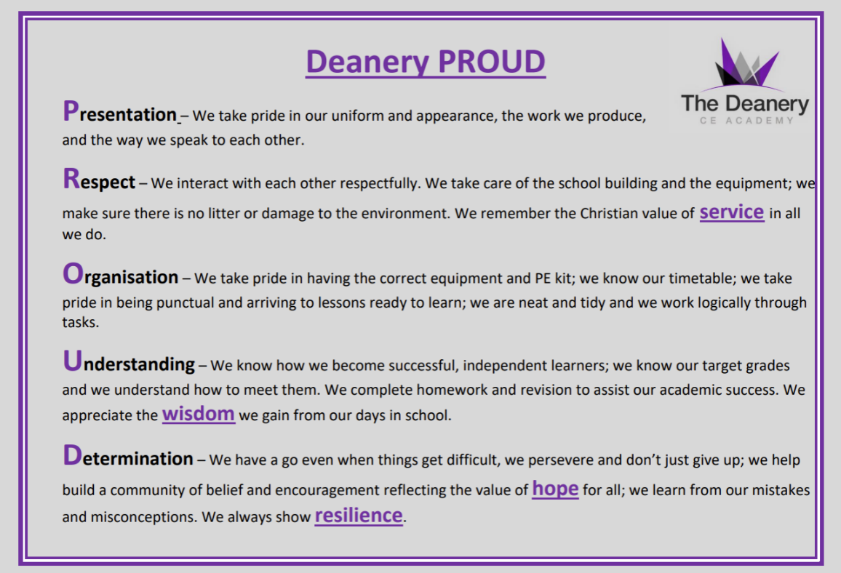

**Staff:**

* Mr Young – Headteacher [youngj@deanerycofeacademy.org.uk](mailto:youngj@deanerycofeacademy.org.uk)
* Mr McDonald - Deputy Headteacher (Curriculum) [mcdonaldd@deanerycofeacademy.org.uk](mailto:mcdonaldd@deanerycofeacademy.org.uk)
* Ms Parry - Assistant Headteacher (Pastoral) [parrys@deanerycofeacademy.org.uk](mailto:parrys@deanerycofeacademy.org.uk)
* Mrs Mathews - Assistant Headteacher (Performing Arts) [matthewsd@deanerycofeacademy.org.uk](mailto:matthewsd@deanerycofeacademy.org.uk)
* Mrs Scotford – Assistant Headteacher (English) [scotforde@deanerycofeacademy.org.uk](mailto:scotforde@deanerycofeacademy.org.uk)
* Miss McCaig - Associate Assistant Headteacher (Mathematics) [mccaigt@deanerycofeacademy.org.uk](mailto:mccaigt@deanerycofeacademy.org.uk)
* Mrs Hockin – Associate Assistant Headteacher (Science) [hockinc@deanerycofeacademy.org.uk](mailto:hockinc@deanerycofeacademy.org.uk)
* Mrs Gallagher - Associate Assistant Headteacher (Humanities) [gallaghers@deanerycofeacademy.org.uk](mailto:gallaghers@deanerycofeacademy.org.uk)

**Dates:**

* Year 11 mock exams are scheduled to take place between the **10th– 21st of November** and **2nd-9th March**.
* Year 11 Subject Consultation Evening is **Wednesday 17th December 4-7pm.**
* Summer Public exam dates are now finalised and will take place between the **4th of May and 26th of June 2026**. Parents should note there are the 26th June is a contingency session in next year’s timetable. Pupils must ensure they remain available on this date, in the event of national or significant local disruption to examinations in the UK during the exam season that may cause exams to be postponed.
* GCSE results are scheduled to be released to pupils on the **20st of August 2026**.

**Key Information:**

**Key Facts**

**Qualification Name:** GCSE Mathematics

**Type:** GCSE

**Assessment:** 100% Examination

**Examination Board:** Edexcel

**Ebacc Subject:** Yes

**Further Information:** Miss McCaig [mccaigt@deanerycofeacademy.org.uk](mailto:mccaigt@deanerycofeacademy.org.uk)

**Maths**

**Revision:**

* Sparx
* Enrichment on Tuesdays
* Pearson Edexcel Grades 9-1 revision guides

**Higher Tier 100% examination**

**Achievable grades:** 3-9

Paper 1 - Non-calculator, 90 minutes, 60 marks

Paper 2 - Calculator, 90 minutes, 60 marks

Paper 3 - Calculator, 90 minutes, 60 marks

**Foundation Tier 100% examination**

**Achievable grades:** 1-5

Paper 1 - Non-calculator, 90 minutes, 60 marks

Paper 2 - Calculator, 90 minutes, 60 marks

Paper 3 - Calculator, 90 minutes, 60 marks

|  |  |  |  |  |
| --- | --- | --- | --- | --- |
| Examination code | Title | Date | Time | Duration |
| 1MA1 1F | Paper 1 (Non-Calculator) Foundation Tier | Thursday 14th May | AM | 1h 30m |
| 1MA1 1H | Paper 1 (Non-Calculator) Higher Tier | Thursday 14th May | AM | 1h 30m |
| 1MA1 2F | Paper 2 (Calculator) Foundation Tier | Wednesday 3rd June | AM | 1h 30m |
| 1MA1 2H | Paper 2 (Calculator) Higher Tier | Wednesday 3rd June | AM | 1h 30m |
| 1MA1 3F | Paper 3 (Calculator) Foundation Tier | Wednesday 10th June | AM | 1h 30m |
| 1MA1 3H | Paper 3 (Calculator) Higher Tier | Wednesday 10th June | AM | 1h 30m |

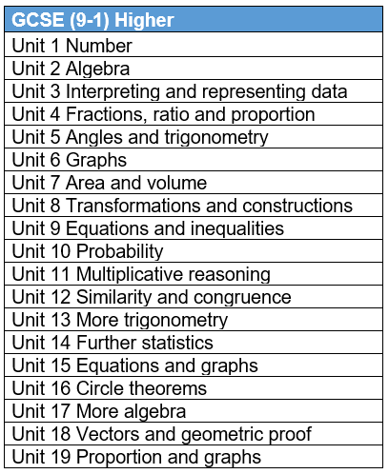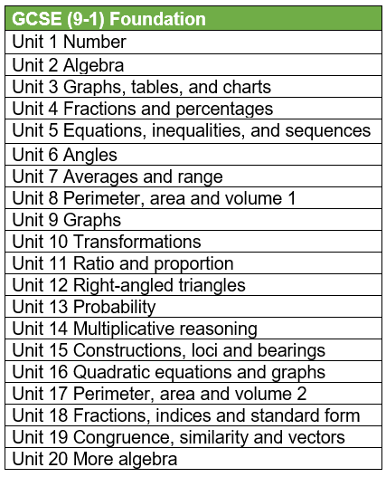

**Revision:**

-Enrichment: Thursdays 3:30-4:30

-Homework: Tassomai & Pink Book Essay Prep

- Website: Knowledge Organizers, past papers & online links www.dcea.org.uk/parent-information/our-curriculum/subjects/english/

**Key Facts**

**Qualification Name:** GCSE English Language

**Type:** GCSE

**Assessment:** 100% Examination – 2 exam papers

**Tiered:** No – all students sit the same papers

**Examination Board:** AQA

**Ebacc Subject:** Yes

**Further Information:** Mrs. Scotford (scotforde@deanerycofeacademy.org.uk)

**English Language**

**Spoken Word**

Separate compulsory element

Individual presentation to the class

|  |  |  |  |  |  |
| --- | --- | --- | --- | --- | --- |
| **Exam Paper** | **Length of Exam** | **Topic** | **Questions** | **Marks** | **/160** |
| Language Paper 1  50% of Language GCSE | 1hr  45mins | Explorations in Creative Reading and Writing:  1x Fiction extract | Reading:  4 multiple choice questions  2 longer form questions  1 extended question | /4  2x /8  /20 | /80 |
| Writing:  1 extended writing question | /24 content & organisation  /16 SPAG |
| Language Paper 2  50% of Language GCSE | 1hr45mins | Writer’s viewpoints and perspectives: 2x Non Fiction extracts | Reading:  1 short form question  2 longer form questions  1 extended comparison question | /4  1x /8 1x /12  /24 | /80 |
| Writing:  1 extended writing question | /24 content & organisation  /16 SPAG  */* |

**Key Facts**

**Qualification Name:** GCSE English Literature

**Type:** GCSE

**Assessment:** 100% Examination – 2 exam papers

**Tiered:** No – all students sit the same papers

**Examination Board:** AQA

**Ebacc Subject:** Yes

**Further Information:** Mrs. Scotford (scotforde@deanerycofeacademy.org.uk)

**Revision:**

-Enrichment: Thursdays 3:30-4:30 1-02

-Homework: Tassomai & Pink Book Essay Prep

- Website: Knowledge Organizers, key quotations, past papers & online links www.dcea.org.uk/parent-information/our-curriculum/subjects/english/

**English Literature**

|  |  |  |  |  |
| --- | --- | --- | --- | --- |
| **Exam Paper** | **Length of Exam** | **Questions** | **Marks** | **/160** |
| Literature Paper 1  40% of Literature GCSE | 1hr45mins | Macbeth | 30 + 4 SPAG | /64 |
| A Christmas Carol | 30 |
| Literature Paper 2  60% of Literature GCSE | 2hr15mins | An Inspector Calls | 30 + 4 SPAG | /96 |
| Power and Conflict Poetry | 30 |
| *Unseen Poetry (1 poem)* | *24* |
| *Compare unseen poems* | *8* |

**Exam Dates:**

**English Language Paper 1: 21st May 2026**

**English Language Paper 2: 5th June 2026**

**English Literature Paper 1: 11th May 2026**

**English Literature Paper 2: 19th May 2026**

**Biology**

**Key Facts**

**Qualification Name:** GCSE Biology

**Assessment:** 100% Examination

**Examination Board:** AQA

**Further Information:** Mrs Hockin

[hockinc@deanerycofeacademy.org.uk](mailto:hockinc@deanerycofeacademy.org.uk)

**How Assessed?**

|  |  |  |  |  |
| --- | --- | --- | --- | --- |
| Examination code | Title | Date | Time | Duration |
| 8461/1F | Paper 1 Foundation Tier - Biology | 12th May 2026 | Afternoon | 1h 45m |
| 8461/1H | Paper 1 Higher Tier - Biology | 12th May 2026 | Afternoon | 1h 45m |
| 8461/2F | Paper 2 Foundation Tier - Biology | 8th June 2026 | Morning | 1h 45m |
| 8461/2H | Paper 2 Higher Tier - Biology | 8th June 2026 | Morning | 1h 45m |

* Multiple choice, structured, closed short answer and open response
* Each paper worth 100 marks

Higher Tier - 100% examination

Achievable grades: 5-9

Paper 1 – Topics 1 -4

Paper 2 – Topics 5 -7

Plus Key Ideas

Foundation Tier - 100% examination

Achievable grades: 1 -5

Paper 1 – Topics 1 -4

Paper 2 – Topics 5-7

Plus Key Ideas

**Subject Content**

* 1. Cell biology
* 2. Organisation
* 3. Infection and response
* 4. Bioenergetics
* 5. Homeostasis and response
* 6. Inheritance, variation and evolution
* 7. Ecology
* 8. Key ideas

**Revision:**

Wednesday Afternoon – 3.30 – 4.30 - Science Corridor

CGP Biology Revision Guide – Foundation or Higher

<https://www.aqa.org.uk/subjects/science/gcse/biology-8461/specification-at-a-glance>

<https://www.physicsandmathstutor.com/biology-revision/gcse-aqa/>

**Key Facts**

**Qualification Name:** GCSE Chemistry

**Assessment:** 100% Examination

**Examination Board:** AQA

**Further Information:** Mrs Hockin

[hockinc@deanerycofeacademy.org.uk](mailto:hockinc@deanerycofeacademy.org.uk)

**Chemistry**

**How Assessed?**

|  |  |  |  |  |
| --- | --- | --- | --- | --- |
| Examination code | Title | Date | Time | Duration |
| 8462/1F | Paper 1 Foundation Tier - Chemistry | 18th May 2026 | Morning | 1h 45m |
| 8462/1H | Paper 1 Higher Tier - Chemistry | 18th May 2026 | Morning | 1h 45m |
| 8462/2F | Paper 2 Foundation Tier - Chemistry | 12th June 2026 | Morning | 1h 45m |
| 8462/2H | Paper 2 Higher Tier - Chemistry | 12th June 2026 | Morning | 1h 45m |

* Multiple choice, structured, closed short answer and open response
* Each paper worth 100 marks

Foundation Tier - 100% examination

Achievable grades: 1 -5

Paper 1 – Topics 1 -5

Paper 2 – Topics 6 -10

Higher Tier - 100% examination

Achievable grades: 5-9

Paper 1 – Topics 1 -5

Paper 2 – Topics 6 -10

**Subject Content**

* 1. Atomic structure and the periodic table
* 2. Bonding, structure, and the properties of matter
* 3. Quantitative chemistry
* 4. Chemical changes
* 5. Energy changes
* 6. The rate and extent of chemical change
* 7. Organic chemistry
* 8. Chemical analysis
* 9. Chemistry of the atmosphere
* 10. Using Resources

**Revision:**

Wednesday Afternoon – 3.30 – 4.30 - Science Corridor

CGP Chemistry Revision Guide – Foundation or Higher

<https://www.aqa.org.uk/subjects/science/gcse/chemistry-8462/specification-at-a-glance>

<https://www.physicsandmathstutor.com/chemistry-revision/gcse-aqa/>

**Physics**

**Key Facts**

**Qualification Name:** GCSE Physics

**Assessment:** 100% Examination

**Examination Board:** AQA

**Further Information:** Mrs Hockin

[hockinc@deanerycofeacademy.org.uk](mailto:hockinc@deanerycofeacademy.org.uk)

**How Assessed?**

|  |  |  |  |  |
| --- | --- | --- | --- | --- |
| Examination code | Title | Date | Time | Duration |
| 8463/1F | Paper 1 Foundation Tier – Physics | 2nd June 2026 | Morning | 1h 45m |
| 8463/1H | Paper 1 Higher Tier - Physics | 2nd June 2026 | Morning | 1h 45m |
| 8463/2F | Paper 2 Foundation Tier - Physics | 15th June 2026 | Morning | 1h 45m |
| 8463/2H | Paper 2 Higher Tier - Physics | 15th June 2026 | Morning | 1h 45m |

* Multiple choice, structured, closed short answer and open response
* Each paper worth 100 marks

Higher Tier - 100% examination

Achievable grades: 5-9

Paper 1 – Topics 1 -4

Paper 2 – Topics 5 -8

Foundation Tier - 100% examination

Achievable grades: 1 -5

Paper 1 – Topics 1 -4

Paper 2 – Topics 5-8

**Subject Content**

* 1. Energy
* 2. Electricity
* 3. Particle model of matter
* 4. Atomic structure
* 5. Forces
* 6. Waves
* 7. Magnetism and electromagnetism
* 8. Space

**Revision:**

Wednesday Afternoon – 3.30 – 4.30 - Science Corridor

CGP Physics Revision Guide – Foundation or Higher

<https://www.aqa.org.uk/subjects/science/gcse/physics-8463/specification-at-a-glance>

<https://www.physicsandmathstutor.com/physics-revision/gcse-aqa/>

**Science**

**Key Facts**

**Qualification Name:** GCSE Combined Science - Trilogy

**Assessment:** 100% Examination

**Examination Board:** AQA

**Further Information:** Mrs Hockin

[hockinc@deanerycofeacademy.org.uk](mailto:hockinc@deanerycofeacademy.org.uk)

**How Assessed?**

There are six papers: two biology, two chemistry and two physics. Each of the papers will assess knowledge and understanding from distinct topic areas. **This examination is worth two Grades.**

|  |  |  |  |  |
| --- | --- | --- | --- | --- |
| Examination code | Title | Date | Time | Duration |
| 8464/B/1F | Paper 1 Foundation Tier - Biology | 12th May 2026 | Afternoon | 1h 15m |
| 8464/B/1H | Paper 1 Higher Tier - Biology | 12th May 2026 | Afternoon | 1h 15m |
| 8464/B/2F | Paper 2 Foundation Tier - Biology | 8th June 2026 | Morning | 1h 15m |
| 8464/B/2H | Paper 2 Higher Tier - Biology | 8th June 2026 | Morning | 1h 15m |
| 8464/C/1F | Paper 1 Foundation Tier - Chemistry | 18th May 2026 | Morning | 1h 15m |
| 8464/C/1H | Paper 1 Higher Tier - Chemistry | 18th May 2026 | Morning | 1h 15m |
| 8464/C/2F | Paper 2 Foundation Tier - Chemistry | 12th June 2026 | Morning | 1h 15m |
| 8464/C/2H | Paper 2 Higher Tier - Chemistry | 12th June 2026 | Morning | 1h 15m |
| 8464/P/1F | Paper 1 Foundation Tier - Physics | 2nd June 2026 | Morning | 1h 15m |
| 8464/P/1H | Paper 1 Higher Tier - Physics | 2nd June 2026 | Morning | 1h 15m |
| 8464/P/2F | Paper 2 Foundation Tier - Physics | 15th June 2026 | Morning | 1h 15m |
| 8464/P/2H | Paper 2 Higher Tier - Physics | 15th June 2026 | Morning | 1h 15m |

* Multiple choice, structured, closed short answer and open response

Higher Tier - 100% examination

Achievable grades: 5-9

Each Paper worth 70 marks

Foundation Tier - 100% examination

Achievable grades: 1 -5

Each paper worth 70 marks

|  |  |  |
| --- | --- | --- |
| Examination code | Title | Subject Content |
| 8464/B/1F | Paper 1 Foundation Tier - Biology | Topics 1 - 4 |
| 8464/B/1H | Paper 1 Higher Tier - Biology | Topics 1 - 4 |
| 8464/B/2F | Paper 2 Foundation Tier - Biology | Topics 5 – 7 |
| 8464/B/2H | Paper 2 Higher Tier - Biology | Topics 5 – 7 |
| 8464/C/1F | Paper 1 Foundation Tier - Chemistry | Topics 8 - 12 |
| 8464/C/1H | Paper 1 Higher Tier - Chemistry | Topics 8 - 12 |
| 8464/C/2F | Paper 2 Foundation Tier - Chemistry | Topics 13 - 17 |
| 8464/C/2H | Paper 2 Higher Tier - Chemistry | Topics 13 – 17 |
| 8464/P/1F | Paper 1 Foundation Tier - Physics | Topics 18 – 21 |
| 8464/P/1H | Paper 1 Higher Tier - Physics | Topics 18 – 21 |
| 8464/P/2F | Paper 2 Foundation Tier - Physics | Topics 22 – 24 |
| 8464/P/2H | Paper 2 Higher Tier - Physics | Topics 22 – 24 |

**Subject Content**

Biology

* 1. Cell biology
* 2. Organisation
* 3. Infection and response
* 4. Bioenergetics
* 5. Homeostasis and response
* 6. Inheritance, variation and evolution
* 7. Ecology

Chemistry

* 8. Atomic structure and the periodic table
* 9. Bonding, structure, and the properties of matter
* 10. Quantitative chemistry
* 11. Chemical changes
* 12. Energy changes
* 13. The rate and extent of chemical change
* 14. Organic chemistry
* 15. Chemical analysis
* 16. Chemistry of the atmosphere
* 17. Using resources

Physics

* 18. Energy
* 19. Electricity
* 20. Particle model of matter
* 21. Atomic structure
* 22. Forces
* 23. Waves
* 24. Magnetism and electromagnetism

**Revision:**

Wednesday Afternoon – 3.30 – 4.30 - Science Corridor

CGP Combined Science Revision Guide – Foundation or Higher

<https://www.aqa.org.uk/subjects/science/gcse/combined-science-trilogy-8464/specification-at-a-glance>

<https://dev.physicsandmathstutor.com/biology-revision/gcse-aqa/>

<https://dev.physicsandmathstutor.com/chemistry-revision/gcse-aqa/>

<https://dev.physicsandmathstutor.com/physics-revision/gcse-aqa/>

**Key facts**

**Qualification Name**: GCSE Religious Studies A

**Type:** GCSE

**Assessment**: 100% Exam

**Examination Board**: AQA

**EBacc Subject**: No

[gallaghers@deanerycofeacademy.org.uk](mailto:gallaghers@deanerycofeacademy.org.uk)

**Paper 1 = Study of two religions**: *Christianity & Islam*

***(1hr 45mins exam)***

**Paper 2 = Study of 4 themes:**

*1. Religion & life*

*2. Religion, peace & conflict*

*3.Religion, crime & punishment*

*4.Religion, human rights & social justice*

***(1hr 45mins exam)***

***The full specification can be found here:*** <https://www.aqa.org.uk/subjects/religious-studies/gcse/religious-studies-a-8062/subject-content/component-1-the-study-of-religions-beliefs,-teachings-and-practices>

**Religious**

**Studies**

Religious Studies allows learners to develop and grow their skills of enquiry and evaluation, and allows us to ask those big questions in the context of our lives and the lives of our worldly neighbours. Religious Studies enables learners to engage with the beliefs and cultures of others and will develop those skills needed to work well with others. This is a subject which helps us to make sense of how the world works and helps learners to engage with others in a positive and understanding way.

The Oak Academy has some brilliant lessons, which cover what we need to know and will be a good revision tool:

<https://classroom.thenational.academy/subjects-by-key-stage/key-stage-4/subjects/religious-education>

Additionally, BBC Bitesize also has some useful revision and quizzes to test your knowledge:<https://www.bbc.co.uk/bitesize/examspecs/zjgx47h>

All knowledge organisers are also available on the school website: <https://www.dcea.org.uk/parent-information/our-curriculum/subjects/religious-education/>

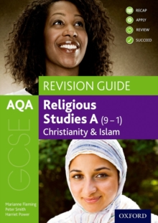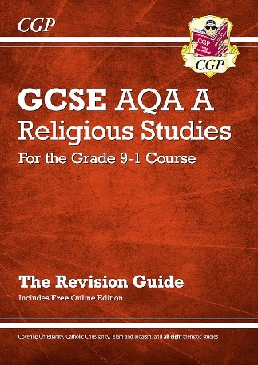

Should you wish to purchase a revision guide to assist your revision, we recommend these.

**GCSE RS revision top tips!**

1. **Learn key quotes:** and how to use them! Make a bank of top quotes and read, cover, recall and repeat
2. **Make a revision timetable:** don’t just revise what you’re already confident in. Make sure you focus on your weaker areas! Little and often is more productive than in big chunks.
3. **Practice answering exam questions:** in timed conditions. Your RE teacher will happily mark these for you and provide feedback.

**Revision**

Revision is an independent task that requires three key components; motivation, cognition (learning to take place) and metacognition (a check to see how effective your learning has been).

**Motivation**

**Dos**

1. Be realistic with how much time you are going to spend revising.
2. Revise for periods of 30 minutes to 1 hour a day, 2 hours as a maximum.
3. If it helps create a timetable of when you are going to revise and the subjects you want to revise during those times. “Monday 5:30 -6:00 maths, 6:15-6:45 science”.
4. Ensure your revision doesn’t clash with things you enjoy such as sports and clubs. Make time to enjoy yourself and relax.
5. Set up a dedicated space that you are going to revise in. It helps if this is in a quiet place and away from where you sleep or watch TV.

**Don’ts**

1. Don’t try to do too much too quickly or conversely don’t leave everything until the last minute. Year 11 is a marathon not a sprint.
2. Don’t spend too much time revising (said no teacher or parent ever), but seriously don’t try and take in too much information at once or you will just forget most of it. It is better to revise “little and often”.
3. Try not to have any distractions in the background, it is easy to give into temptation.
4. Try not to revise when you are really hungry or tired, try to make the time you spend revising “high quality” revision time.
5. Only revise in groups or with friends if you are actually going to revise.

**Cognition**

There are marks in most exams for three main areas:

AO1: Knowledge recall, being able to state facts.

AO2: Apply your knowledge, usually by describing or explaining.

AO3: Linking of knowledge and understanding, usually analysis or evaluation style questions,

Each style of question (Assessment Objectives) builds upon the skills needed for the previous. It is good therefore to start your revision with the recall of key facts and then build this into trying past exam questions later when you have built-up and refreshed your knowledge.

The following revision strategies generally work well for each;

AO1 – Knowledge recall

1. Creating or using flash-cards
2. Creating or reading knowledge organisers
3. Watching You-Tube clips
4. Multiple choice quizzes
5. Reading revision guides or textbooks and making notes

AO2 – Applying knowledge

1. Try summary questions in revision guides or textbooks
2. Practice some past exam questions and check these with the mark scheme.
3. Try some online quizzes.
4. Ask friends and family to question you on a particular topic using key command works from the exam “describe or explain”.
5. Ask your teacher for subject specific advice.

AO3 – Linking your knowledge

1. Try whole past exam papers. You may want to do this with a textbook or revision guide and no time limit to start with and then build up to the most effective technique which is to do past papers in timed exam conditions.
2. Use the mark scheme to mark your own paper. You could then even swap papers with friends and mark each other’s to see if you gave yourself the same mark as they did. Arguing about why there maybe a difference can be helpful for you to see your mistakes more clearly.
3. Read the mark-scheme and annotate both the past paper and the mark-scheme, you may know all of the content, but you need to become fluent in the language of exams.
4. Ask your teacher for a past paper question to take home, bring it to them ask them to go over it with you.
5. If you are secure in your understanding, you could write your own exam questions and mark scheme to go with them. You could even ask your friends to do the question and discuss how good your question was.

**Metacognition**

It is important that you don’t just waste time revising stuff you already know or use revision techniques that don’t suite how you learn. There are a few things that you can do to make sure your revision is more effective.

1. Use a checklist that is linked to the specification, these can be provided or have been in many cases already provided to you. Use the checklist to highlight areas you need to work on and focus on these.
2. Check your understanding of content you have revised by completing a quiz.
3. Check your understanding of content you have revised by completing a past exam question on that topic and marking it using the mark-scheme. Be careful to consider if you knew the content but just didn’t understand the question… if this is the case you need to practice more past papers rather than revise more content.
4. Practice a past paper first, particularly in maths, if you did well on a certain topic revise this last and prioritise other topics or questions you may be struggling with first.
5. Think about how productive you are being. Did you really need to make that pretty picture or could you have printed it off/sketched it roughly instead?
6. Think about how effective that revision strategy is for you. If you are making a million and one flash cards but cannot remember anything you wrote on them, perhaps think about using a different strategy.
7. Make the most of your strengths, if you learn a lot watching YouTube clips this isn’t necessarily less effective than writing lots of notes.
8. Think about how you can best use your time to get the best outcome. Is there a point to what I am doing? Could I be doing something that is more effective?
9. Practice past paper questions to test and examine your current grade and work on how you approach the exam. How could you improve the way in which you approach the paper? Would it be good to read the question again before answering? Are you answering the question being asked or are you answering the one you thought was being asked?
10. Don’t panic if you don’t get your desired grade in a past paper, have a growth mindset. Ask yourself “how can I do better next time?”, then make adjustments and improvements to reach your goal.

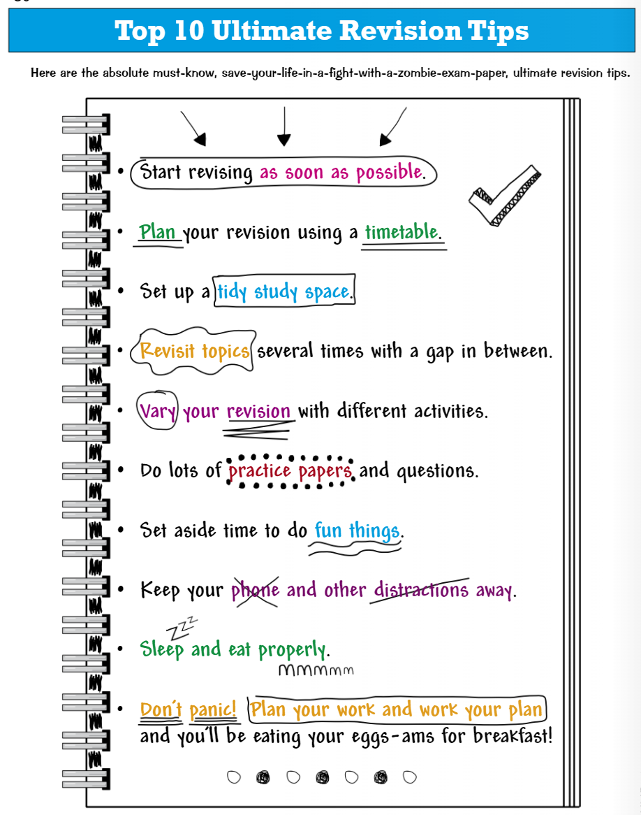

**Useful Revision Tools**









