**Year 10 Parent Information**

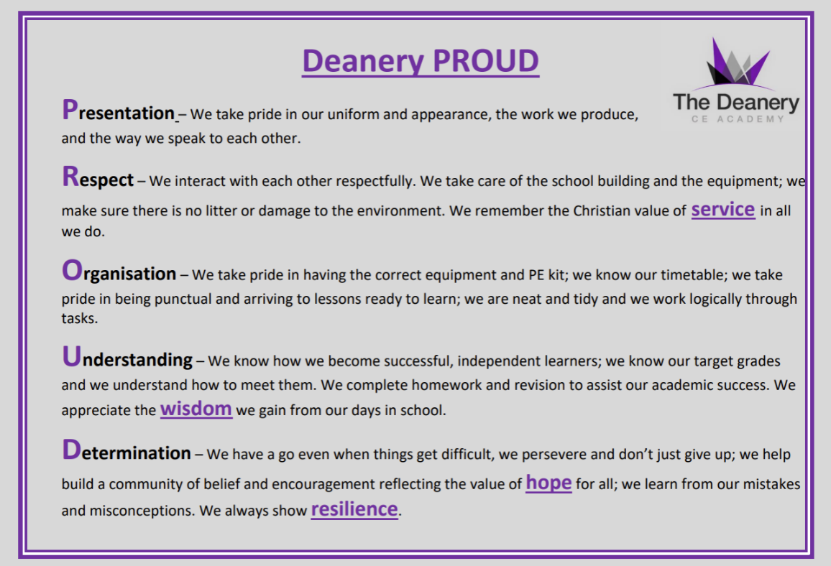

Edexcel Examination Board

* Maths
* History
* Computer Science

Pearson Examination Board

* Health & Social Care

OCR Examination Board

* Drama
* PE
* Sport Studies

**Staff:**

* Mr Young – Headteacher [youngj@deanerycofeacademy.org.uk](mailto:youngj@deanerycofeacademy.org.uk)
* Mr McDonald - Deputy Headteacher (Curriculum) [mcdonaldd@deanerycofeacademy.org.uk](mailto:mcdonaldd@deanerycofeacademy.org.uk)
* Ms Parry - Assistant Headteacher (Pastoral) [parrys@deanerycofeacademy.org.uk](mailto:parrys@deanerycofeacademy.org.uk)
* Mrs Mathews - Assistant Headteacher (Performing Arts) [matthewsd@deanerycofeacademy.org.uk](mailto:matthewsd@deanerycofeacademy.org.uk)
* Mrs Scotford – Assistant Headteacher (English) [scotforde@deanerycofeacademy.org.uk](mailto:scotforde@deanerycofeacademy.org.uk)
* Mrs Hockin – Associate Assistant Headteacher (Science) [hockinc@deanerycofeacademy.org.uk](mailto:hockinc@deanerycofeacademy.org.uk)
* Mrs Gallagher - Associate Assistant Headteacher (Humanities) [gallaghers@deanerycofeacademy.org.uk](mailto:gallaghers@deanerycofeacademy.org.uk)
* Miss McCaig – Associate Assistant Headteacher (Maths) mccaigt@deanerycofeacademy.org.uk

WJEC Examination Board

* Hospitality and Catering

AQA Examination Board

* English
* Science
* Religious Studies
* Geography
* French
* Textiles
* Photography
* Fine Art

**Revision:**

* Sparx
* Enrichment on Tuesdays (from July in year 10)
* Pearson Edexcel Grades 9-1 revision guides

**Foundation Tier 100% examination**

**Achievable grades:** 1-5

Paper 1 - Non-calculator, 90 minutes, 60 marks

Paper 2 - Calculator, 90 minutes, 60 marks

Paper 3 - Calculator, 90 minutes, 60 marks

**Key Facts**

**Qualification Name:** GCSE Mathematics

**Type:** GCSE

**Assessment:** 100% Examination

**Examination Board:** Edexcel

**Ebacc Subject:** Yes

**Further Information:** Miss McCaig – Associate Assistant Headteacher (Maths) mccaigt@deanerycofeacademy.org.uk

**Maths**

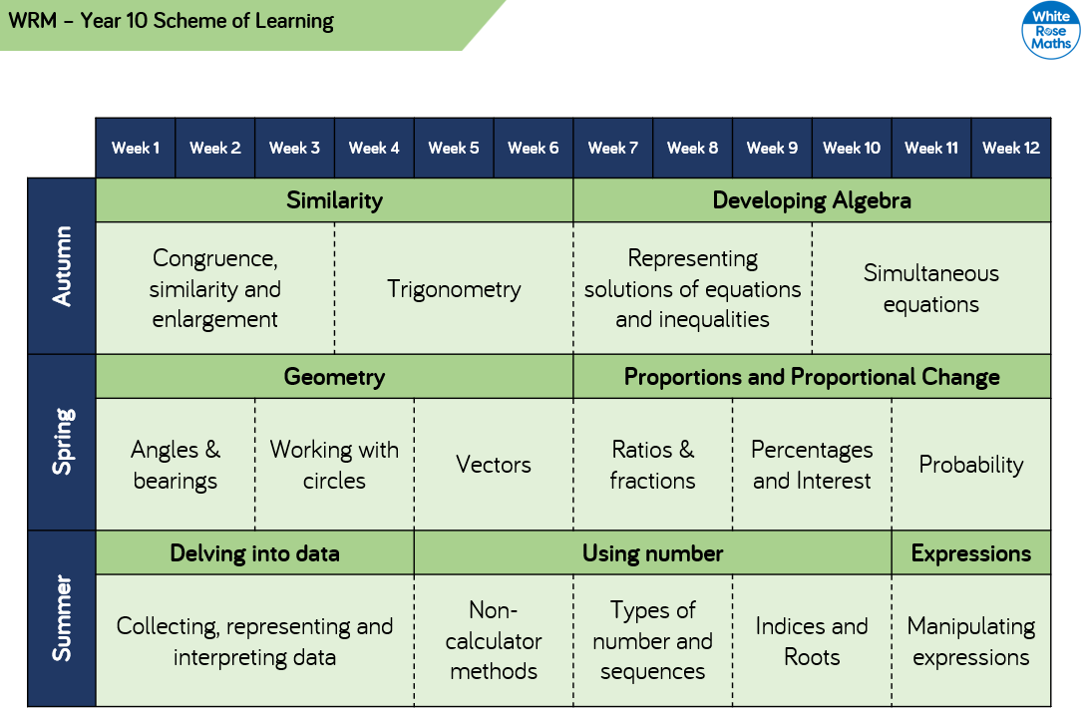

**Higher Tier 100% examination**

**Achievable grades:** 3-9

Paper 1 - Non-calculator, 90 minutes, 60 marks

Paper 2 - Calculator, 90 minutes, 60 marks

Paper 3 - Calculator, 90 minutes, 60 marks

**Revision:**

-Homework: Tassomai

- Website: Knowledge Organizers, past papers & online links www.dcea.org.uk/parent-information/our-curriculum/subjects/english/

**Key Facts**

**Qualification Name:** GCSE English Language

**Type:** GCSE

**Assessment:** 100% Examination – 2 exam papers

**Tiered:** No – all students sit the same papers

**Examination Board:** AQA

**Ebacc Subject:** Yes

**Further Information:** Mrs. Scotford (scotforde@deanerycofeacademy.org.uk)

**English Language**

**Spoken Word**

Separate compulsory element

Individual presentation to the class

|  |  |  |  |  |  |
| --- | --- | --- | --- | --- | --- |
| **Exam Paper** | **Length of Exam** | **Topic** | **Questions** | **Marks** | **/160** |
| Language Paper 1  50% of Language GCSE | 1hr  45mins | Explorations in Creative Reading and Writing:  1x Fiction extract | Reading:  1 short form question  2 longer form questions  1 extended question | /4  2x /8  /20 | /80 |
| Writing:  1 extended writing question | /24 content & organisation  /16 SPAG |
| Language Paper 2  50% of Language GCSE | 1hr45mins | Writer’s viewpoints and perspectives: 2x Non Fiction extracts | Reading:  1 short form question  2 longer form questions  1 extended comparison question | /4  1x /8 1x /12  /24 | /80 |
| Writing:  1 extended writing question | /24 content & organisation  /16 SPAG  */* |

**Key Facts**

**Qualification Name:** GCSE English Literature

**Type:** GCSE

**Assessment:** 100% Examination – 2 exam papers

**Tiered:** No – all students sit the same papers

**Examination Board:** AQA

**Ebacc Subject:** Yes

**Further Information:** Mrs. Scotford (scotforde@deanerycofeacademy.org.uk)

**Revision:**

-Homework: Tassomai

- Website: Knowledge Organizers, key quotations, past papers & online links www.dcea.org.uk/parent-information/our-curriculum/subjects/english/

**English Literature**

|  |  |  |  |  |
| --- | --- | --- | --- | --- |
| **Exam Paper** | **Length of Exam** | **Questions** | **Marks** | **/160** |
| Literature Paper 1  40% of Literature GCSE | 1hr45mins | Macbeth | 30 + 4 SPAG | /64 |
| A Christmas Carol | 30 |
| Literature Paper 2  60% of Literature GCSE | 2hr15mins | An Inspector Calls | 30 + 4 SPAG | /96 |
| Power and Conflict Poetry | 30 |
| *Unseen Poetry (1 poem)* | *24* |
| *Compare unseen poems* | *8* |

**Biology**

Higher Tier - 100% examination

Achievable grades: 5-9

Paper 1 – Topics 1 -4

Paper 2 – Topics 5 -7

Plus Key Ideas

Foundation Tier - 100% examination

Achievable grades: 1 -5

Paper 1 – Topics 1 -4

Paper 2 – Topics 5-7

Plus Key Ideas

**Key Facts**

**Qualification Name:** GCSE Biology

**Assessment:** 100% Examination

**Examination Board:** AQA

**Further Information:** Mrs Hockin

[hockinc@deanerycofeacademy.org.uk](mailto:hockinc@deanerycofeacademy.org.uk)

**Subject Content**

* 1. Cell biology
* 2. Organisation
* 3. Infection and response
* 4. Bioenergetics
* 5. Homeostasis and response
* 6. Inheritance, variation and evolution
* 7. Ecology
* 8. Key ideas

**Revision:**

CGP Biology Revision Guide – Foundation or Higher

<https://www.aqa.org.uk/subjects/science/gcse/biology-8461/specification-at-a-glance>

<https://www.physicsandmathstutor.com/biology-revision/gcse-aqa/>

**Chemistry**

Higher Tier - 100% examination

Achievable grades: 5-9

Paper 1 – Topics 1 -5

Paper 2 – Topics 6 -10

Foundation Tier - 100% examination

Achievable grades: 1 -5

Paper 1 – Topics 1 -5

Paper 2 – Topics 6 -10

**Key Facts**

**Qualification Name:** GCSE Chemistry

**Assessment:** 100% Examination

**Examination Board:** AQA

**Further Information:** Mrs Hockin

[hockinc@deanerycofeacademy.org.uk](mailto:hockinc@deanerycofeacademy.org.uk)

**Subject Content**

* 1. Atomic structure and the periodic table
* 2. Bonding, structure, and the properties of matter
* 3. Quantitative chemistry
* 4. Chemical changes
* 5. Energy changes
* 6. The rate and extent of chemical change
* 7. Organic chemistry
* 8. Chemical analysis
* 9. Chemistry of the atmosphere
* 10. Using Resources

**Revision:**

CGP Chemistry Revision Guide – Foundation or Higher

<https://www.aqa.org.uk/subjects/science/gcse/chemistry-8462/specification-at-a-glance>

<https://www.physicsandmathstutor.com/chemistry-revision/gcse-aqa/>

**Physics**

Higher Tier - 100% examination

Achievable grades: 5-9

Paper 1 – Topics 1 -4

Paper 2 – Topics 5 -8

**Key Facts**

**Qualification Name:** GCSE Physics

**Assessment:** 100% Examination

**Examination Board:** AQA

**Further Information:** Mrs Hockin

[hockinc@deanerycofeacademy.org.uk](mailto:hockinc@deanerycofeacademy.org.uk)

Foundation Tier - 100% examination

Achievable grades: 1 -5

Paper 1 – Topics 1 -4

Paper 2 – Topics 5-8

**Subject Content**

* 1. Energy
* 2. Electricity
* 3. Particle model of matter
* 4. Atomic structure
* 5. Forces
* 6. Waves
* 7. Magnetism and electromagnetism
* 8. Space

**Revision:**

CGP Physics Revision Guide – Foundation or Higher

<https://www.aqa.org.uk/subjects/science/gcse/physics-8463/specification-at-a-glance>

<https://www.physicsandmathstutor.com/physics-revision/gcse-aqa/>

**Science**

Higher Tier - 100% examination

Achievable grades: 5-9

Each Paper worth 70 marks

Foundation Tier - 100% examination

Achievable grades: 1 -5

Each paper worth 70 marks

|  |  |  |
| --- | --- | --- |
| Examination code | Title | Subject Content |
| 8464/B/1F | Paper 1 Foundation Tier - Biology | Topics 1 - 4 |
| 8464/B/1H | Paper 1 Higher Tier - Biology | Topics 1 - 4 |
| 8464/B/2F | Paper 2 Foundation Tier - Biology | Topics 5 – 7 |
| 8464/B/2H | Paper 2 Higher Tier - Biology | Topics 5 – 7 |
| 8464/C/1F | Paper 1 Foundation Tier - Chemistry | Topics 8 - 12 |
| 8464/C/1H | Paper 1 Higher Tier - Chemistry | Topics 8 - 12 |
| 8464/C/2F | Paper 2 Foundation Tier - Chemistry | Topics 13 - 17 |
| 8464/C/2H | Paper 2 Higher Tier - Chemistry | Topics 13 – 17 |
| 8464/P/1F | Paper 1 Foundation Tier - Physics | Topics 18 – 21 |
| 8464/P/1H | Paper 1 Higher Tier - Physics | Topics 18 – 21 |
| 8464/P/2F | Paper 2 Foundation Tier - Physics | Topics 22 – 24 |
| 8464/P/2H | Paper 2 Higher Tier - Physics | Topics 22 – 24 |

**Key Facts**

**Qualification Name:** GCSE Combined Science - Trilogy

**Assessment:** 100% Examination

**Examination Board:** AQA

**Further Information:** Mrs Hockin

[hockinc@deanerycofeacademy.org.uk](mailto:hockinc@deanerycofeacademy.org.uk)

**Subject Content**

Biology

* 1. Cell biology
* 2. Organisation
* 3. Infection and response
* 4. Bioenergetics
* 5. Homeostasis and response
* 6. Inheritance, variation and evolution
* 7. Ecology

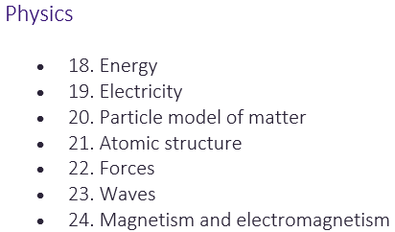Chemistry

* 8. Atomic structure and the periodic table
* 9. Bonding, structure, and the properties of matter
* 10. Quantitative chemistry
* 11. Chemical changes
* 12. Energy changes
* 13. The rate and extent of chemical change
* 14. Organic chemistry
* 15. Chemical analysis
* 16. Chemistry of the atmosphere
* 17. Using resources

**Revision:**

CGP Combined Science Revision Guide – Foundation or Higher

<https://www.aqa.org.uk/subjects/science/gcse/combined-science-trilogy-8464/specification-at-a-glance>

<https://dev.physicsandmathstutor.com/biology-revision/gcse-aqa/>

<https://dev.physicsandmathstutor.com/chemistry-revision/gcse-aqa/>

<https://dev.physicsandmathstutor.com/physics-revision/gcse-aqa/>

**Key facts**

**Qualification Name**: GCSE Religious Studies A

**Type:** GCSE

**Assessment**: 100% Exam

**Examination Board**: AQA

**EBacc Subject**: No

[gallaghers@deanerycofeacademy.org.uk](mailto:gallaghers@deanerycofeacademy.org.uk)

**Paper 1 = Study of two religions**: *Christianity & Islam*

***(1hr 45mins exam)***

**Paper 2 = Study of 4 themes:**

*1. Religion & life*

*2. Religion, peace & conflict*

*3.Religion, crime & punishment*

*4.Religion, human rights & social justice*

***(1hr 45mins exam)***

***The full specification can be found here:*** <https://www.aqa.org.uk/subjects/religious-studies/gcse/religious-studies-a-8062/subject-content/component-1-the-study-of-religions-beliefs,-teachings-and-practices>

**Religious**

**Studies**

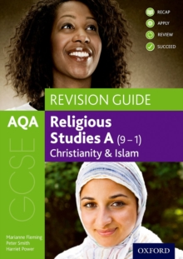

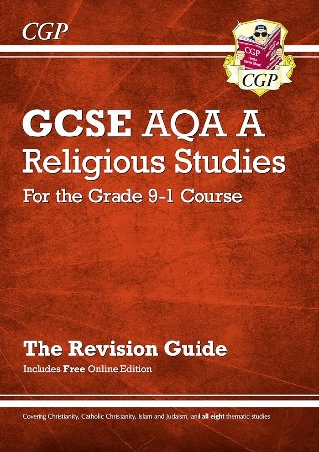

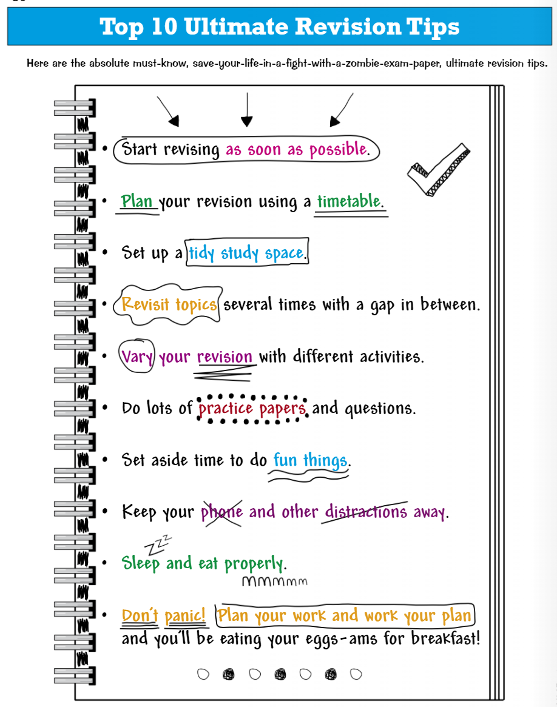

**Useful Revision Tools**







