**Attendance Policy**

The Deanery CE Academy



|  |  |  |  |  |
| --- | --- | --- | --- | --- |
| **Approved March 2024 by: Laura Connors and Governors** |  | **Date:** |  |  |
|  |
| **Last reviewed on: September 2024** |  |  | | |
| **Next review due by: September 2024** |  |  | | |

Table of Contents

1. Aims 3

2. Legislation and guidance 3

3. Roles and responsibilities 4

4. Recording attendance 6

5. Authorised and unauthorised absence 8

6. Strategies for promoting attendance 9

7. Attendance monitoring 9

8. Monitoring arrangements 10

9. Links with other policies 10

Appendix 1: attendance codes 11

# 1. Aims

We are committed to meeting our obligation with regards to school attendance through our whole-school culture and ethos that values good attendance, including:

* Promoting good attendance
* Reducing absence, including persistent and severe absence
* Ensuring every student has access to the full-time education to which they are entitled
* Acting early to address patterns of absence
* Building strong relationships with families to ensure students have the support in place to attend school
* We will also promote and support punctuality in attending lessons.

# 2. Legislation and guidance

This policy meets the requirements of the [working together to improve school attendance](https://www.gov.uk/government/publications/working-together-to-improve-school-attendance) from the

Department for Education (DfE), and refers to the DfE’s statutory guidance on [school attendance parental responsibility measures.](https://www.gov.uk/government/publications/parental-responsibility-measures-for-behaviour-and-attendance) These documents are drawn from the following legislation setting out the legal powers and duties that govern school attendance:

* Part 6 of [The Education Act 1996](https://www.legislation.gov.uk/ukpga/1996/56/contents) o
* Part 3 of [The Education Act 2002](https://www.legislation.gov.uk/ukpga/2002/32/contents) o
* Part 7 of [The Education and Inspections Act 2006](https://www.legislation.gov.uk/ukpga/2006/40/contents)
* [The Education (Learner Registration) (England) Regulations 2006 (and 2010, 2011, 2013, 2016 amendments)](https://www.legislation.gov.uk/uksi/2006/1751/contents/made)
* [The Education (Penalty Notices) (England) (Amendment) Regulations 2013](https://www.legislation.gov.uk/uksi/2013/757/regulation/2/made)

This policy also refers to the DfE’s guidance on the [school census,](https://www.gov.uk/guidance/complete-the-school-census) which explains the persistent absence threshold.

# 3. Roles and responsibilities

### 3.1 The Academy

The Academy is responsible for:

* Promoting the importance of school attendance across the school’s policies and ethos
* Making sure school leaders fulfil expectations and statutory duties
* Regularly reviewing and challenging attendance data
* Monitoring attendance figures for the whole school
* Making sure staff receive adequate training on attendance
* Holding the headteacher to account for the implementation of this policy

### The headteacher

The headteacher is responsible for:

* Implementation of this policy at the school
* Monitoring school-level absence data and reporting it to Academy Council
* Supporting staff with monitoring the attendance of individual students
* Monitoring the impact of any implemented attendance strategies
* Issuing fixed-penalty notices, where necessary

### 3.3 The designated senior leader responsible for attendance

The designated senior leader is responsible for:

* Leading attendance across the school
* Offering a clear vision for attendance improvement
* Evaluating and monitoring expectations and processes
* Having an oversight of data analysis
* Devising specific strategies to address areas of poor attendance identified through data
* Arranging calls and meetings with parents to discuss attendance issues
* Delivering targeted intervention and support to students and families

### The attendance Officer

The school attendance officer is responsible for:

* Monitoring and analysing attendance data (see section 7)
* Benchmarking attendance data to identify areas of focus for improvement
* Providing regular attendance reports to school staff and reporting concerns about attendance to the designated senior leader responsible for attendance and the headteacher
* Working with head of year, tutors, students and their families to improve attendance
* Working with education welfare officers to tackle persistent absence
* Advising the headteacher (authorised by the headteacher) when to issue fixed-penalty notices

### 3.5 Class Teacher &Tutor

Class teachers/tutors are responsible for recording attendance for each lesson on a daily basis.

### 3.6 School admin staff

School admin staff will:

* Take calls from parents about absence on a day-to-day basis and record it on the school system
* Transfer calls from parents to the Head of Year/Assistant Head of Year in order to provide them with more detailed support on attendance

### Parents/carers

Parents/carers are expected to:

* Make sure their child attends every day on time
* Call the school to report their child’s absence before 08:30 on the day of the absence and each subsequent day of absence, and advise when they are expected to return
* Ensure that, where possible, appointments for their child are made outside of the school day
* Provide the school with more than 1 emergency contact number for their child

### 3.8 Students

students are expected to:

* Attend school every day on time
* Attend every timetabled session on time

# 4. Recording attendance

### 4.1 Attendance register

We will keep an attendance register and place all students onto this register.

We will take our attendance register at the start of the first session of each school day and every lesson thereafter. It will mark whether every student is:

* Present
* Attending an approved off-site educational activity (pre-populated by attendance)
* Absent
* Unable to attend due to exceptional circumstances (pre-populated by attendance)
* Late (plus enter minutes late)

Any amendment to the attendance register will include:

* The original entry
* The amended entry
* The reason for the amendment
* The date on which the amendment was made
* The name and position of the person who made the amendment See appendix 1 for the DfE attendance codes.

We will also record:

* Whether the absence is authorised or not
* The nature of the activity if a student is attending an approved educational activity
* The nature of circumstances where a student is unable to attend due to exceptional circumstance
* We will keep every entry on the attendance register for 3 years after the date on which the entry was made.

Students must arrive in school by 08:45 on each school day. The gates close at 08:45am for roll call.

The register for the first session will be taken between 8:45 – 08:55. Students who arrive between 08:55 and 09:05 will be marked as late for registration ( L code ). Students arriving after 09:05 will be marked as arriving after registration has closed ( U code ).

### 4.2 Unplanned absence

The parent/carer must notify the school of the reason for the absence on the first day of an unplanned absence by 08:30 or as soon as practically possible by calling the school admin staff (see also section 7) or using the ARBOR application.

Please use the ARBOR app or call 01793 236611.

We will mark absence due to illness as authorised unless the school has a genuine concern about the authenticity of the illness.

If the authenticity of the illness is in doubt, the school may ask the parent/carer to provide medical evidence, such as a doctor’s note, prescription, appointment card or other appropriate form of evidence. We will not ask for medical evidence unnecessarily.

If the school is not satisfied about the authenticity of the illness, the absence will be recorded as unauthorised and parents/carers will be notified of this in advance. Parents may be asked for medical evidence for ongoing illness.

More information relating to attendance can be found here <https://www.swindon.gov.uk/info/20032/schools_and_education/1275/school_attendance>

**4.3 Planned absence**

We encourage parents/carers to make medical and dental appointments out of school hours where possible. Where this is not possible, the student should be out of school for the minimum amount of time necessary.

Please email your child’s tutor in advance of this absence, and copy in admin@deanerycofeacademy.org.uk

Attending a medical or dental appointment will be counted as authorised as long as the parent/carer notifies the school in advance of the appointment.

The parent/carer must also apply for other types of term-time absence as far in advance as possible of the requested absence. Go to section 5 to find out which term-time absences the school can authorise.

**4.4 Lateness and punctuality**

A student who arrives late:

* Before the register has closed will be marked as late, using the appropriate code
* After the register has closed will be marked as absent, using the appropriate code

Persistent lateness, will trigger a meeting request from the tutor, Head of Year and/or attendance lead. Detentions will be issued for lateness.

### Following up unexplained absence

Where any student we expect to attend school does not attend, or stops attending, without reason, the school (admin team (first day of absence), attendance officer (repeated absence) will:

1. Call/message the student’s parent/carer on the morning of the first day of unexplained absence to ascertain the reason. If the school cannot reach any of the student’s emergency contacts, the school may contact the Police.
2. Identify whether the absence is approved or not
3. Identify the correct attendance code to use and input it as soon as the reason for absence is ascertained – this will be no later than 5 working days after the session
4. Call the parent/carer on each day that the absence continues without explanation to ensure proper safeguarding action is taken where necessary. If absence continues, the school will consider involving an education welfare officer
5. Home visit (unannounced) if we have not sighted for 5 days or safeguarding concerns

More information relating to unexplained absence can be found here

<https://hubforeducation.swindon.gov.uk/Pages/Download/137caac8-54be-4dcb-85be-97f066585e80/PageSectionDocuments>

### 4.6 Reporting to parents/carers

The Deanery CE Academy will report their child’s attendance data yearly through the school report at the end of the school year. Parents will also receive percentage attendance letters when their child’s attendance falls below 90% which is considered ‘persistently absent’.

# 5. Authorised and unauthorised absence

### 5.1 Approval for term-time absence

The headteacher may only grant a leave of absence to a student during term time if they consider there to be 'exceptional circumstances'. A leave of absence is granted at the headteacher’s discretion, including the length of time the student is authorised to be absent for.

The school considers each application for term-time absence individually, considering the specific facts, circumstances and relevant context behind the request.

Any request should be submitted as soon as it is anticipated and, where possible, at least two weeks before the absence, and in accordance with any leave of absence request form, accessible via emailing admin@deanerycofeacademy.org.uk. The headteacher may require evidence to support any request for leave of absence.

Valid reasons for **authorised absence** include:

* Illness and medical/dental appointments (see sections 4.2 and 4.3 for more detail) Religious observance – where the day is exclusively set apart for religious observance by the religious body to which the student’s parents belong. If necessary, the school will seek advice from the parents’ religious body to confirm whether the day is set apart
* Traveller students travelling for occupational purposes– this covers Roma, English and Welsh gypsies, Irish and Scottish travellers, showmen (fairground people) and circus people, bargees (occupational boat dwellers) and new travellers. Absence may be authorised only when a traveller family is known to be travelling for occupational purposes and has agreed this with the school, but it is not known whether the student is attending educational provision

### Legal sanctions

Parents or guardians of students of compulsory school age have a legal duty to ensure that their children receive efficient, full-time education by attendance at school or otherwise under the provisions of the education act 1996.

If any child of compulsory school age who is a registered student at a school fails to attend regularly at the school, his / her parent is guilty of an offence. Section 444A and section 444B of the Education Act 1996 give powers to the Local Authority to issue Penalty Notices where a parent or carer is considered capable of, but unwilling to secure an improvement in their child’s school attendance.

The school or local authority can fine parents / carers for the unauthorised absence of their child from school, where the child is of compulsory school age. Penalty notices can be issued by a Principal, local authority officer or the police.

The decision on whether or not to issue a penalty notice may take into account:

The number of unauthorised absences occurring within a rolling academic year

One-off instances of irregular attendance, such as holidays taken in term time without permission

Where a suspended pupil is found in a public place during school hours without a justifiable reason

If the payment has not been made after 28 days, the local authority can decide whether to prosecute or withdraw the notice.

Schools will be required to consider a fine when a child has missed 10 or more sessions (5 days) for unauthorised reasons. The fine for school absences will be £80 if paid within 21 days, or £160 if paid within 28 days. In the case of repeated fines, if a parent receives a second fine for the same child within any three-year period, this will be charged at the higher rate of £160. Fines per parent will be capped to two fines within any three-year period. Once this limit has been reached, other action like a parenting order or prosecution will be considered.

# 6. Strategies for promoting attendance

We promote attendance during school assemblies, building resilience through our curriculum, and building a sense of self through our wellbeing curriculum, along with tutor groups, reward points for attendance and punctuality throughout the day and positive welcoming staff.

All staff are key to encouraging good attendance.

Tutors or leaders can often discuss attendance issues and put support in place before they become a problem.

Tutors and leaders contact parents directly to discuss potential problems and pre-empt attendance issues that may arise, e.g. such as when a supply teacher is taking a class which may cause anxiety, or when a trip is planned and we are aware that the student may try to have a day off due to anxieties around changes.

# 7. Attendance monitoring

The attendance lead at our school monitors students absence on a weekly basis.

### Monitoring attendance

The school will:

* Monitor attendance and absence data half-termly, termly and yearly across the school and at an individual student level
* Identify whether or not there are particular groups of children whose absences may be a cause for concern

Absence data will be collected each term and published at national and local authority level through the DfE's school absence national statistics releases. The underlying school-level absence data is published alongside the national statistics. The school will compare attendance data to the national average, and share this with the governing board.

### Analysing attendance

The school will:

* Analyse attendance and absence data regularly to identify student or cohorts that need additional support with their attendance, and use this analysis to provide targeted support to these students and their families
* Look at historic and emerging patterns of attendance and absence, and then develop strategies to address these patterns

### Using data to improve attendance

The school will:

* Provide regular attendance reports to tutors, and other school leaders, to facilitate discussions with student and families
* Use data to monitor and evaluate the impact of any interventions put in place in order to modify them and inform future strategies

### 7.4 Reducing persistent and severe absence

Persistent absence is where a student misses 10% or more of school, and severe absence is where a student misses 50% or more of school.

The school will:

* Use attendance data to find patterns and trends of persistent and severe absence
* Hold regular meetings with the parents of students who the school (and/or local authority) considers to be vulnerable, or are persistently or severely absent, to discuss attendance and engagement at school
* Provide access to wider support services to remove the barriers to attendance

See appendix 2 for attendance procedures

# 8. Monitoring arrangements

This policy will be reviewed as guidance from the local authority or DfE is updated, and as a minimum two years by The Deputy Headteacher (Pastoral). At every review, the policy will be approved by the full governing board.

# 9. Links with other policies

This policy links to the following policies:

* Child protection and safeguarding policy
* Behaviour policy

## Appendix 1: attendance codes

The following codes are taken from the DfE’s guidance on school attendance.

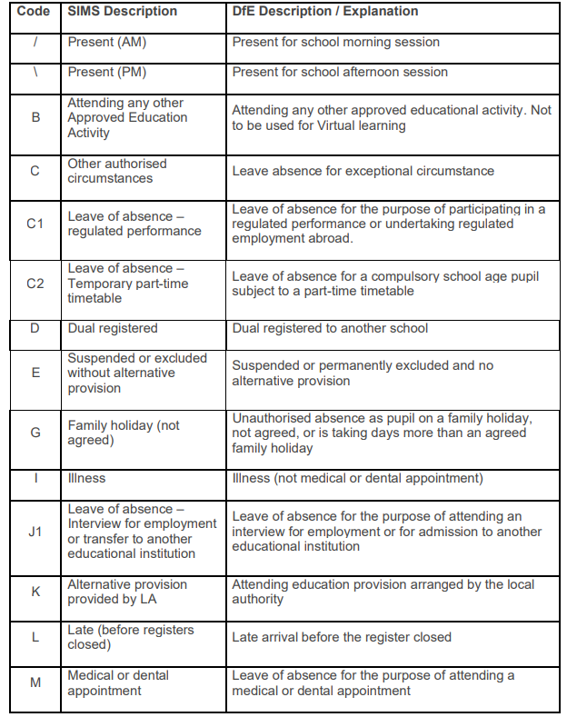

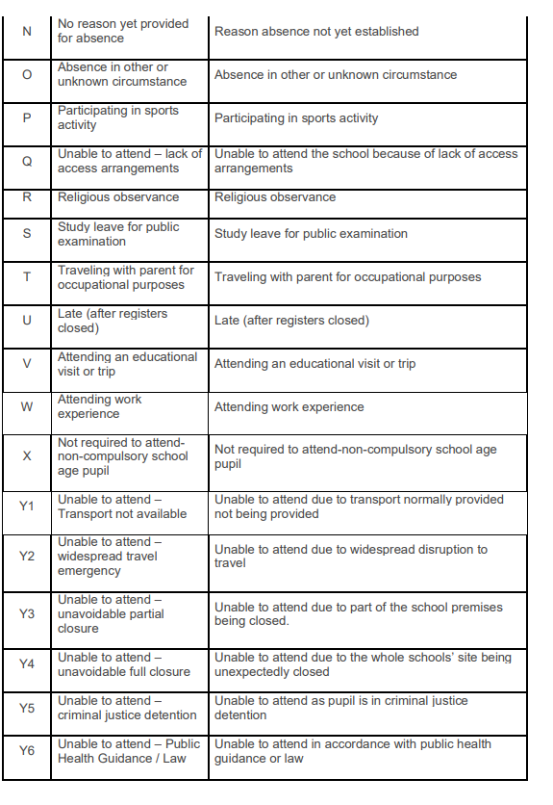

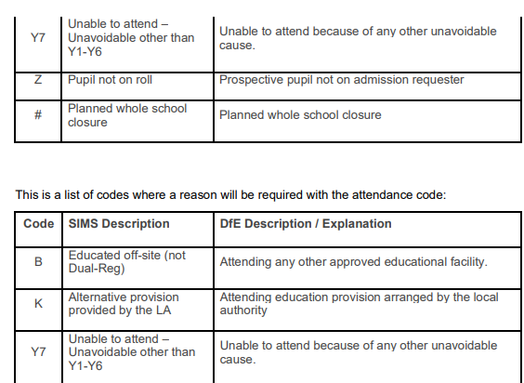

Appendix 2:

|  |  |  |  |
| --- | --- | --- | --- |
| **Attendance Category** | **Description** | **When will our attendance procedure be activated?** | **What stage will our attendance procedures be activated?** |
| A – Good Attenders  Students who attended the academy well | Those with 97% cumulative attendance the previous year | After October half term but only if student drops below our threshold of 97% attendance | **Stage 1**  Attendance Officer  Good attenders receive rewards |
| B- Regular attenders  Students who have attended the academy regularly | Those who are 90—97% | Immediately but only if student attendance drops below our threshold of 97% attendance | **Stage 1**  Monitored by the attendance officer  Discussed with tutor  Letter 1 sent home |
| C- Persistently Absent  Students who were persistently absent | Those with attendance below 90% | Immediately but only is student drops below our threshold of 97% attendance | **Stage 2**  Letter 2 sent home  Head of Year Attendance Plan  4 week attendance monitoring plan  Students must not miss any sessions during this period.  If they do, will move to stage 3 |
| D – Severely Absent  Students who were severely absent | Those with attendance below 50% or have not made any progress during 4 week plan | Immediately but only if student attendance drops below our threshold of 97% | **Stage 3**  Letter 3 Sent home  Attendance Officer 4 –week plan  If no improvement, fixed penalty notice and Education Welfare Officer referral. |
| Child Missing in Education | Child missing for up to 3- days | Immediately | The academy will take action to trace the child |
| Child missing in Education | Child missing for 10-20 continuous days | Immediately | The academy will work with the local authority to trace the pupil. If the pupil is not traceable, the pupil will be removed from the role and a child missing in education form will be completed by the local authority.  Where pupils have moved away, pupils will not be removed from roll until a new school has been confirmed. |

### 