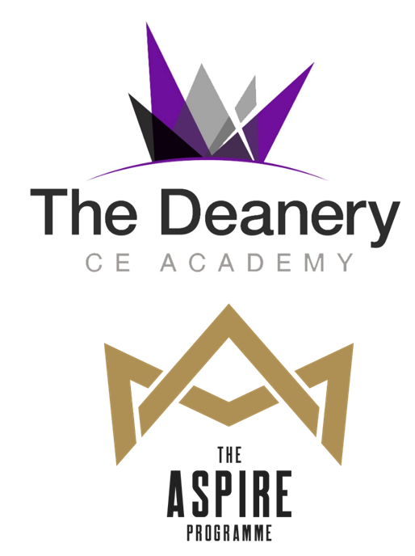

**Learner Log Book**

Name:

Tutor Group:

The Deanery CE Academy Aspire Programme is a series of academically focused activities designed to challenge you. There are a diverse range activities from classroom based challenges or lunchtime activities including online lectures delivered by industry sector experts.

The Deanery Aspire Programme will expand your horizons and provide you with opportunities to develop yourself to be a leader of the future. You will have the opportunity to gain recognition for the skills you develop in school time and for the opportunities you partake in outside of school time.

You will be able to achieve points by completing the following activities:

* Aspire activities in class (1 point per activity)
* Demonstrating skills through the skills builder programme (10 points per skill)
* Attending lectures/talks (virtual or in person) (10 points per talk)
* Completing a mini dissertation on a subject of interest (30 points per 500 words)
* Competitions (40 points per entry)

To achieve a Deanery Aspire bronze, silver or gold award you must achieve 50, 100 or 200 points respectively, and have completed the log book for your completed activities. To achieve gold you must have completed your mini dissertation and at least two other areas.

This log book explains what you need to do for each of the activities listed above. You can achieve your points in one activity area or ideally across a range of activity areas.

Submission of your log book and dissertation is due on 1st July 2022. You must submit your work to Ms Main. If you are continuing to the next academic year with your award then you can submit the following July.

Enjoy your journey and achieving your prestigious Deanery Aspire pin badge and certificate. We look forward to celebrating your achievements in the summer term.

If you have questions please email Ms Main on [Elizabeth.main@dcea.org.uk](mailto:Elizabeth.main@dcea.org.uk)

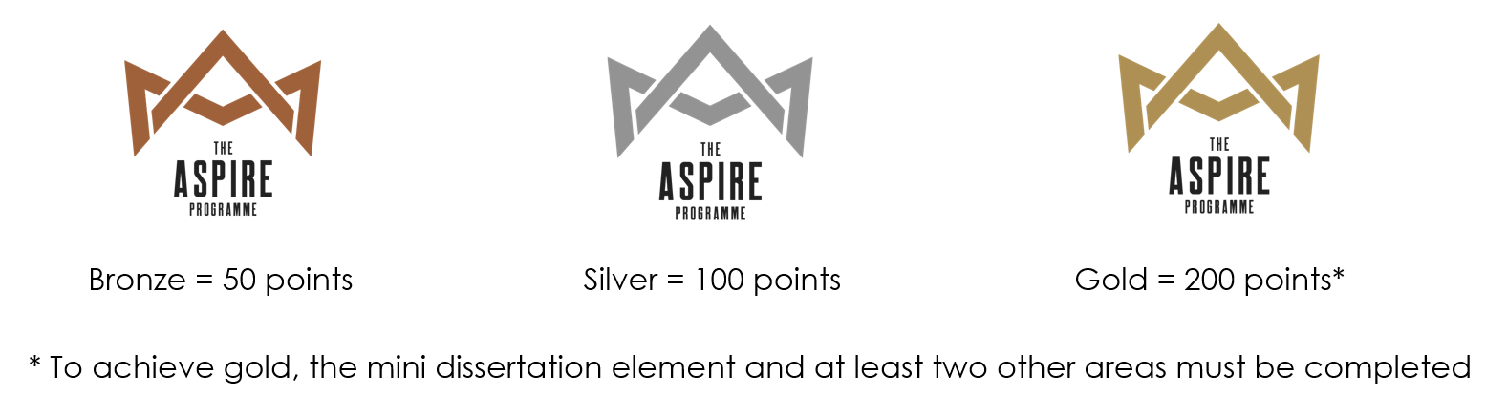

# 

# Aspire Activities (1 point per activity)

Each time you complete an Aspire task get your teacher to initial below:

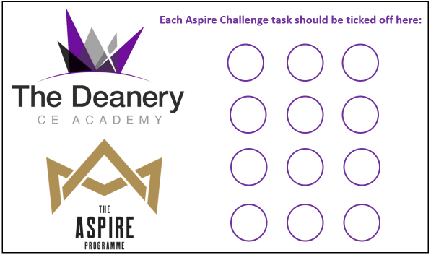







I have completed Aspire tasks in the following subjects:

You have achieved points in Aspire challenges.

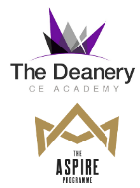

# Skills builder (10 points per skill)

Read the skills builder steps for each skill. These are the skills you need to be a successful student and in your future careers. When you think you have evidence for a skill step, write an explanation of what you have done and ask your teacher or tutor to sign off your achievement. **You must have two pieces of evidence to gain scholar points for a skill.** If you need help visit Ms Main on a Wednesday lunch time in her office (opposite 1-11).

|  |  |  |  |
| --- | --- | --- | --- |
| **Skill** | **Skill Step** | **Evidence** | **Teacher Sign Off** |
|  |  |  |  |
|  |  |  |
|  |  |  |  |
|  |  |  |
|  |  |  |  |
|  |  |  |
|  |  |  |  |
|  |  |  |

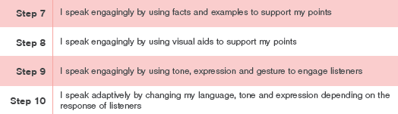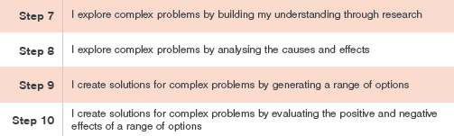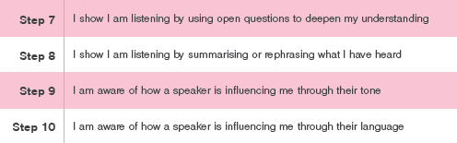



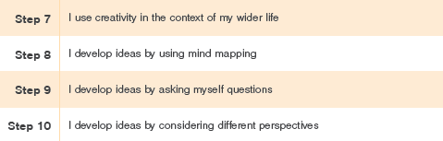

|  |  |  |  |
| --- | --- | --- | --- |
| **Skill** | **Skill Step** | **Evidence** | **Teacher**  **Sign Off** |
|  |  |  |  |
|  |  |  |
|  |  |  |  |
|  |  |  |
|  |  |  |  |
|  |  |  |
|  |  |  |  |
|  |  |  |

You have achieved points in skills builder.

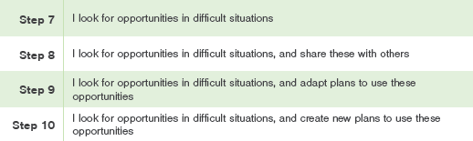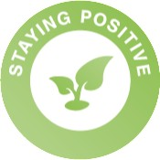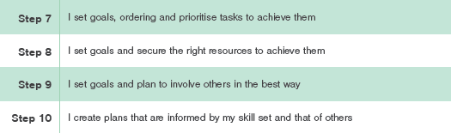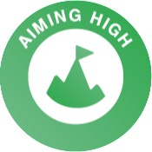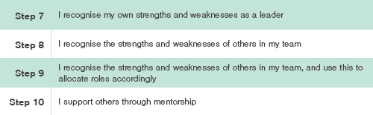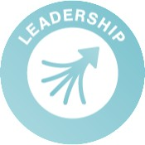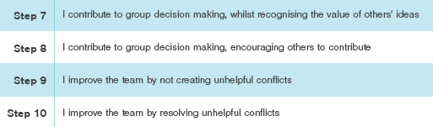



# Lectures and Talks (10 points per talk)

The following are a series of talks you can access online that will expand your horizons in a variety of subject areas. There will be further in person talks announced once the speakers are confirmed. They are either career related videos or lectures from university lecturers on current areas of academic research. Each talk will last between 20 minutes and an hour. You need to write in your log book notes on the talk you have watched.

|  |  |  |
| --- | --- | --- |
| **Title** | **Subjects** | **Link / Date** |
| **Beethoven’s fit of rage!** | **Music** | <https://www.youtube.com/watch?v=JReC_0GSpbk> |
| **The story of a Paralympian: Anna Turney** | **Sport** | [Anna Turney, Paralympian - Speakers for](https://www.speakersforschools.org/vtalks/anna-turney-paralympian/) <https://www.speakersforschools.org/vtalks/anna-turney-paralympian/> |
| **The story of an entrepreneur** | **Business** | <https://www.speakersforschools.org/vtalks/mark-maciver/> |
| **How to survive in space** | **Technology Science**  **Engineering** | [The next frontier | The Royal Institution:](https://www.rigb.org/christmas-lectures/watch/2015/how-to-survive-in-space/the-next-frontier) <https://www.rigb.org/christmas-lectures/watch/2015/how-to-survive-in-space/the-next-frontier> |
| **The Simplest Math Problem No One Can Solve - Collatz Conjecture** | **Maths (challenging)** | <https://youtu.be/094y1Z2wpJg> |
| **Cognitive Science Masterclass: Selective Attention** | **Psychology** | [Cognitive Science Masterclass: Selective](https://www.youtube.com/watch?v=pgCvJgTOx94) <https://www.youtube.com/watch?v=pgCvJgTOx94> |
| **Modern History Masterclass: Religious Minorities in the Time of a Pandemic** | **Religion Sociology**  **History** | <https://www.youtube.com/watch?v=ikoE29P_828> [Minorities in the Time of a Pandemic - YouTube](https://www.youtube.com/watch?v=ikoE29P_828) |
| **History: Understaning Liberalism** | **Politics**  **Sociology History** | <https://www.youtube.com/watch?v=7UPb4Pmv1HI> |
| **How to get into publishing** | **English Publishing** | [How to Get into Publishing, with Simon](https://www.speakersforschools.org/vtalks/how-to-get-into-publishing-with-simon-armstrong-and-hannah-chukwu-virtual-penguin-talk/) <https://www.speakersforschools.org/vtalks/how-to-get-into-publishing-with-simon-armstrong-and-hannah-chukwu-virtual-penguin-talk/>  [Penguin Talk - Speakers for Schools](https://www.speakersforschools.org/vtalks/how-to-get-into-publishing-with-simon-armstrong-and-hannah-chukwu-virtual-penguin-talk/) |
| **Engine Earth: How geology shows the history of climate change.** | **Geology Geography** | [Engine Earth | The Royal Institution: Science](https://www.rigb.org/christmas-lectures/watch/2020/planet-earth-a-users-guide/engine-earth) <https://www.rigb.org/christmas-lectures/watch/2020/planet-earth-a-users-guide/engine-earth> |
| **Water World: How does the Earth heat itself and how does the water system work?** | **Geography Physics** | [Water world | The Royal Institution: Science](https://www.rigb.org/christmas-lectures/watch/2020/planet-earth-a-users-guide/water-world) <https://www.rigb.org/christmas-lectures/watch/2020/planet-earth-a-users-guide/water-world> |
| **Up in the air: What’s really in the air we**  **breathe?** | **Environmental science Physics**  **Geography** | [Up in the air | The Royal Institution: Science](https://www.rigb.org/christmas-lectures/watch/2020/planet-earth-a-users-guide/up-in-the-air) <https://www.rigb.org/christmas-lectures/watch/2020/planet-earth-a-users-guide/up-in-the-air> |
| **How to get lucky!** | **Maths** | [How to get lucky | The Royal Institution:](https://www.rigb.org/christmas-lectures/watch/2019/secrets-and-lies/how-to-get-lucky) <https://www.rigb.org/christmas-lectures/watch/2019/secrets-and-lies/how-to-get-lucky> |
| **How to bend the rules** | **Maths Statistics** | [How to bend the rules | The Royal Institution:](https://www.rigb.org/christmas-lectures/watch/2019/secrets-and-lies/how-to-bend-the-rules) <https://www.rigb.org/christmas-lectures/watch/2019/secrets-and-lies/how-to-bend-the-rules> |
| **How can we all win?** | **Maths** | [How can we all win? | The Royal Institution:](https://www.rigb.org/christmas-lectures/watch/2019/secrets-and-lies/how-can-we-all-win) <https://www.rigb.org/christmas-lectures/watch/2019/secrets-and-lies/how-can-we-all-win> |
| **Say it with sound: What is sound and how does it travel?** | **Physics Biology** | [Say it with sound | The Royal Institution:](https://www.rigb.org/christmas-lectures/watch/2017/the-language-of-life/say-it-with-sound) <https://www.rigb.org/christmas-lectures/watch/2017/the-language-of-life/say-it-with-sound> |
| **Silent messages in the animal kingdom** | **Biology** | <https://www.rigb.org/explore-science/explore/video/language-life-silent-messages-2017> |
| **The word: What is language and how close do other animals come to having it?** | **Languages**  **English** | [The word | The Royal Institution: Science Lives](https://www.rigb.org/christmas-lectures/watch/2017/the-language-of-life/the-word) <https://www.rigb.org/christmas-lectures/watch/2017/the-language-of-life/the-word> |
| **The genius puppetry behind War Horse** | **Drama Art** | [https://www.ted.com/5245ff50-65e4-434c-](https://www.ted.com/5245ff50-65e4-434c-86d8-86c4f28a37f3) [86d8-86c4f28a37f3](https://www.ted.com/5245ff50-65e4-434c-86d8-86c4f28a37f3) |
| **In the internet age, dance evolves…** | **Dance** | [https://www.ted.com/a1423b40-d766-44d5-](https://www.ted.com/a1423b40-d766-44d5-9366-18e76f9d235f) [9366-18e76f9d235f](https://www.ted.com/a1423b40-d766-44d5-9366-18e76f9d235f) |
| **How to write your mini dissertation** | **All** | With Ms Main in The Egg  Date to be announced (will be announced via Satchel) |
| **4 Reasons To Learn A New Language** | **Languages** | <https://ed.ted.com/lessons/i9eDOogu> |
| **How does the brain process speech?** | **Languages**  **English** | <https://ed.ted.com/lessons/how-do-our-brains-process-speech-gareth-gaskell> |
| **How to practice effectively…for just about anything** | **Cognitive Science** | <https://ed.ted.com/lessons/how-to-practice-effectively-for-just-about-anything-annie-bosler-and-don-greene> |
| **Are we born to speak? Planet Word with Stephen Fry** | **English**  **Languages** | <https://www.youtube.com/watch?v=LKUmdTqBLzA> |

You have achieved _ points in lectures.

|  |  |  |  |
| --- | --- | --- | --- |
| **Date** | **Session Title** | **Speaker** | **Attendance Signature**  **(Parent/Carer/**  **Teacher)** |
| **Notes:** | | | |
| **Questions you thought of and would like to ask:** | | | |
| **Summary of Key Learning:** | | | |
| **Reflection: 5 is the most positive response**  How interesting was the session? 1 2 3 4 5  How informative was the session? 1 2 3 4 5  How much did you enjoy the session? 1 2 3 4 5 | | | |
| **Date** | **Session Title** | **Speaker** | **Attendance Signature**  **(Parent/Carer/**  **Teacher)** |
| **Notes:** | | | |
| **Questions you thought of and would like to ask:** | | | |
| **Summary of Key Learning:** | | | |
| **Reflection: 5 is the most positive response**  How interesting was the session? 1 2 3 4 5  How informative was the session? 1 2 3 4 5  How much did you enjoy the session? 1 2 3 4 5 | | | |

|  |  |  |  |
| --- | --- | --- | --- |
| **Date** | **Session Title** | **Speaker** | **Attendance Signature**  **(Parent/Carer/**  **Teacher)** |
| **Notes:** | | | |
| **Questions you thought of and would like to ask:** | | | |
| **Summary of Key Learning:** | | | |
| **Reflection: 5 is the most positive response**  How interesting was the session? 1 2 3 4 5  How informative was the session? 1 2 3 4 5  How much did you enjoy the session? 1 2 3 4 5 | | | |

|  |  |  |  |
| --- | --- | --- | --- |
| **Date** | **Session Title** | **Speaker** | **Attendance Signature**  **(Parent/Carer/**  **Teacher)** |
| **Notes:** | | | |
| **Questions you thought of and would like to ask:** | | | |
| **Summary of Key Learning:** | | | |
| **Reflection: 5 is the most positive response**  How interesting was the session? 1 2 3 4 5  How informative was the session? 1 2 3 4 5  How much did you enjoy the session? 1 2 3 4 5 | | | |

|  |  |  |  |
| --- | --- | --- | --- |
| **Date** | **Session Title** | **Speaker** | **Attendance Signature**  **(Parent/Carer/**  **Teacher)** |
| **Notes:** | | | |
| **Questions you thought of and would like to ask:** | | | |
| **Summary of Key Learning:** | | | |
| **Reflection: 5 is the most positive response**  How interesting was the session? 1 2 3 4 5  How informative was the session? 1 2 3 4 5  How much did you enjoy the session? 1 2 3 4 5 | | | |

|  |  |  |  |
| --- | --- | --- | --- |
| **Date** | **Session Title** | **Speaker** | **Attendance Signature**  **(Parent/Carer/**  **Teacher)** |
| **Notes:** | | | |
| **Questions you thought of and would like to ask:** | | | |
| **Summary of Key Learning:** | | | |
| **Reflection: 5 is the most positive response**  How interesting was the session? 1 2 3 4 5  How informative was the session? 1 2 3 4 5  How much did you enjoy the session? 1 2 3 4 5 | | | |

|  |  |  |  |
| --- | --- | --- | --- |
| **Date** | **Session Title** | **Speaker** | **Attendance Signature**  **(Parent/Carer/**  **Teacher)** |
| **Notes:** | | | |
| **Questions you thought of and would like to ask:** | | | |
| **Summary of Key Learning:** | | | |
| **Reflection: 5 is the most positive response**  How interesting was the session? 1 2 3 4 5  How informative was the session? 1 2 3 4 5  How much did you enjoy the session? 1 2 3 4 5 | | | |
| **Date** | **Session Title** | **Speaker** | **Attendance Signature**  **(Parent/Carer/**  **Teacher)** |
| **Notes:** | | | |
| **Questions you thought of and would like to ask:** | | | |
| **Summary of Key Learning:** | | | |
| **Reflection: 5 is the most positive response**  How interesting was the session? 1 2 3 4 5  How informative was the session? 1 2 3 4 5  How much did you enjoy the session? 1 2 3 4 5 | | | |

|  |  |  |  |
| --- | --- | --- | --- |
| **Date** | **Session Title** | **Speaker** | **Attendance Signature**  **(Parent/Carer/**  **Teacher)** |
| **Notes:** | | | |
| **Questions you thought of and would like to ask:** | | | |
| **Summary of Key Learning:** | | | |
| **Reflection: 5 is the most positive response**  How interesting was the session? 1 2 3 4 5  How informative was the session? 1 2 3 4 5  How much did you enjoy the session? 1 2 3 4 5 | | | |

|  |  |  |  |
| --- | --- | --- | --- |
| **Date** | **Session Title** | **Speaker** | **Attendance Signature**  **(Parent/Carer/**  **Teacher)** |
| **Notes:** | | | |
| **Questions you thought of and would like to ask:** | | | |
| **Summary of Key Learning:** | | | |
| **Reflection: 5 is the most positive response**  How interesting was the session? 1 2 3 4 5  How informative was the session? 1 2 3 4 5  How much did you enjoy the session? 1 2 3 4 5 | | | |

# 

# Mini Dissertation

# (30 points per 500 words)

The dissertation is your opportunity to research a topic of your choice. Your chosen title will have to be researched and referenced as if you were completing an extended project in sixth form or completing a dissertation at university. It must not be copied from another source.

Your topic may be inspired by a talk you have listened to as part of the Aspire Programme or may be based on another area of interest.

You will write up to 1500 words and achieve 30 points for each 500 words. There will also be bonus points that may be awarded when your work is marked if your dissertation is well written and correctly referenced.

You will be taught how to research and how to reference in an Aspire lecture event at lunch time (the date will be given to you nearer the time).

Week 2 Mondays will then be available as a drop in session in Ms Main’s office where you can get help with your dissertation.

When you submit your log book you need to attach your dissertation to your book so it can be marked with your other Aspire activities.

You have achieved ____ points in the mini dissertation.

# Competitions (40 points per entry)

Competitions are a great way to take part in opportunities with people across the country or even the world. Any competitions we find will be send to you via Satchel, you can decide whether or not to enter. If you enter your own competition then add it to the list below. Attach a copy of your entry to your Aspire booklet to gain points. If you need help with making an entry then email [elizabeth.main@dcea.org.uk](mailto:elizabeth.main@dcea.org.uk)

|  |  |  |
| --- | --- | --- |
| **Details** | **Website to submit entry** | **Deadline** |
| **Poetry By Heart** – choose a poem, learn it by heart, perform it out loud! The winners get a chance to perform in Shakespeare’s Globe. If you’re interested, get in touch with Ms Heron. | <https://www.poetrybyheart.org.uk/> | Thursday 31st March 2022, but start your 2023 entry now! |
| **BBC Young Reporter** - It is an opportunity for 11-18 year-olds to report on a story or issue that is important to their life or the world around them – it could be a personal story or related to the experience of family, friends or community, or about an issue or experience particularly relevant to young people. | <https://www.bbc.co.uk/teach/young-reporter/competition/zghcydm> | 27th March 2022! But look out for 2023 entries. |
| **British Science Week 2022 Poster Competition – “Growth”**  Design a poster which explores the idea of ‘growth’. You will be judged on:   * Creativity * Content * Communication of your ideas. | <https://www.britishscienceweek.org/plan-your-activities/poster-competition/> | 15th April 2022. |
| **Biology Challenge 2022**  Open to Y9 students. The competition consists of two, twenty-five-minute multiple choice papers to be taken online under staff supervised exam conditions. Questions will be set on the school curriculum, but the competition will also reward those students whose knowledge of the subject has been increased by reading books and magazines, watching natural history programmes, taking notice of the news media for items of biological interest. | <https://ukbiologycompetitions.org/biology-challenge/> | 2-20th May 2022 |

You have achieved ____ points in competitions.