|  |
| --- |
| **THE DEANERY ADMISSIONS FORM**    **PUPIL DETAILS**    LEGAL SURNAME _________________________    SURNAME KNOWN BY (If different) __________________    NAME __________________________________    DOB ____________________________________    GENDER _______________________________________    ADDRESS  ______________________________________________________________________________  __________________________________________________    POSTCODE _____________________    Please enclose a copy of your child’s birth certificate    If an overseas passport, then proof of residency is required  Date of entry into the UK |

Date induction meeting completed –

Name of staff member hosting the meeting –

Please give a copy to student services to scan onto ARBOR

Please give a copy to the parent.

TRUTEX Uniform website <https://www.trutex.com/>

TRUTEX Uniform code LEA00960SC

|  |
| --- |
| **CONTACT DETAILS**  Please give details of those persons who live with the above pupil. Details of **both** parents are required unless there is a court order in place that prevents a parent from having access to their child or their information.    **PARENT/CARER 1** RELATIONSHIP TO CHILD _________________________    SURNAME ________________________________ FORENAME______________________ TITLE _________ ADDRESS  ______________________________________________________________________________  __________________________________________________ POSTCODE  ___________________________  HOME TEL NO ____________________________ MOBILE  _______________________________________  WORK TEL NO ____________________________  PREFERRED EMAIL ADDRESS  ______________________________________@________________________  Parental responsibility  I give/do not give permission for The Deanery to email/text me with important school matters (Delete as necessary)  Permitted to collect from school    **PARENT/CARER 2** RELATIONSHIP TO CHILD  _________________________  SURNAME ________________________________ FORENAME______________________ TITLE _________ ADDRESS  ______________________________________________________________________________  __________________________________________________ POSTCODE  ___________________________  HOME TEL NO ____________________________ MOBILE  _______________________________________  WORK TEL NO ____________________________  PREFERRED EMAIL ADDRESS  ______________________________________@________________________  Parental responsibility  I give/do not give permission for The Deanery to email/text me with important school matters (Delete as necessary)  Permitted to collect from school |

**Please give details of additional contacts who may be contacted in an emergency in order of priority including any other person with parental responsibility.**

SURNAME ________________________________ FORENAME______________________ TITLE _________

RELATIONSHIP TO CHILD

___________________________________________________________________

ADDRESS

______________________________________________________________________________

__________________________________________________ POSTCODE

___________________________

HOME TEL NO ____________________________ MOBILE

_______________________________________

WORK TEL NO ____________________________

Permitted to collect from school

SURNAME ________________________________ FORENAME______________________ TITLE _________

RELATIONSHIP TO CHILD

___________________________________________________________________

ADDRESS

______________________________________________________________________________

__________________________________________________ POSTCODE

___________________________

HOME TEL NO ____________________________ MOBILE

_______________________________________

WORK TEL NO ____________________________

Permitted to collect from school

# PRIORITY OF CONTACTS – MUST BE FULY COMPLETED

Please indicate the order in w hich contact should be made on a day to day basis or in the event of an emergency CONTACT 1

_____________________________________________________________________________

CONTACT 2

_____________________________________________________________________________

CONTACT 3

_____________________________________________________________________________ CONTACT 4

_____________________________________________________________________________

# FAMILY DETAILS

Please give details of siblings at _______________________________________________ (Primary School)

NAME ________________________________________________ DOB

____________________________

NAME ________________________________________________ DOB

____________________________

NAME ________________________________________________ DOB

**ETHNIC BACKGROUND**

This part of the form is based on the new national population Census ethnic categories.

Please indicate below the ethnicity code which best describes you

|  |  |  |  |  |  |  |  |
| --- | --- | --- | --- | --- | --- | --- | --- |
| Afghan |  |  | Indian |  |  | Roma |  |
| African Asian |  | Information Not Yet Obtained |  | Serbian |  |
| Albanian |  | Iranian |  | Singaporean Chinese |  |
| Arab |  | Iraqi |  | Sri Lankan Other |  |
| Asian and any other ethnic group |  | Italian |  | Sri Lankan Sinhalese |  |
| Asian and Black |  | Japanese |  | Sri Lankan Tamil |  |
| Asian and Chinese |  | Kashmiri other |  | Taiwanese |  |
| Bangladeshi |  | Kashmiri Pakistani |  | Thai |  |
| Black - Angolan |  | Korean |  | Traveller of Irish heritage |  |
| Black - Congolese |  | Kosovan |  | Turkish |  |
| Black - Ghanaian |  | Kurdish |  | Turkish Cypriot |  |
| Black - Nigerian |  | Latin/South/Central American |  | Vietnamese |  |
| Black - Somali |  | Lebanese |  | White - Cornish |  |
| Black - Sudanese |  | Libyan |  | White - English |  |
| Black and any other ethnic group |  | Malay |  | White - Irish |  |
| Black and Chinese |  | Malaysian Chinese |  | White - Scottish |  |
| Black Caribbean |  | Mirpuri Pakistani |  | White - Welsh |  |
| Black European |  | Moroccan |  | White + any other Asian Background |  |
| Black North American |  | Nepali |  | White and any other ethnic group |  |
| Bosnian-Herzegovinian |  | Other Asian |  | White and Black African |  |
| Chinese |  | Other Black |  | White and Black Caribbean |  |

|  |  |  |  |  |  |  |  |
| --- | --- | --- | --- | --- | --- | --- | --- |
| Chinese + any other ethnic group |  |  | Other Black African |  |  | White and chinese |  |
| Croatian |  | Other Chinese |  | White and Indian |  |
| Egyptian |  | Other ethnic group |  | White and Pakistani |  |
| Filipino |  | Other Gypsy/Roma |  | White Eastern European |  |
| Greek |  | Other mixed background |  | White European |  |
| Greek Cypriot |  | Other Pakistani |  | White Other |  |
| Gypsy |  | Other White British |  | White Western European |  |
| Gypsy/Roma |  | Polynesian |  | Yemeni |  |
| Hong Kong Chinese |  | Portuguese |  | Refused |  |

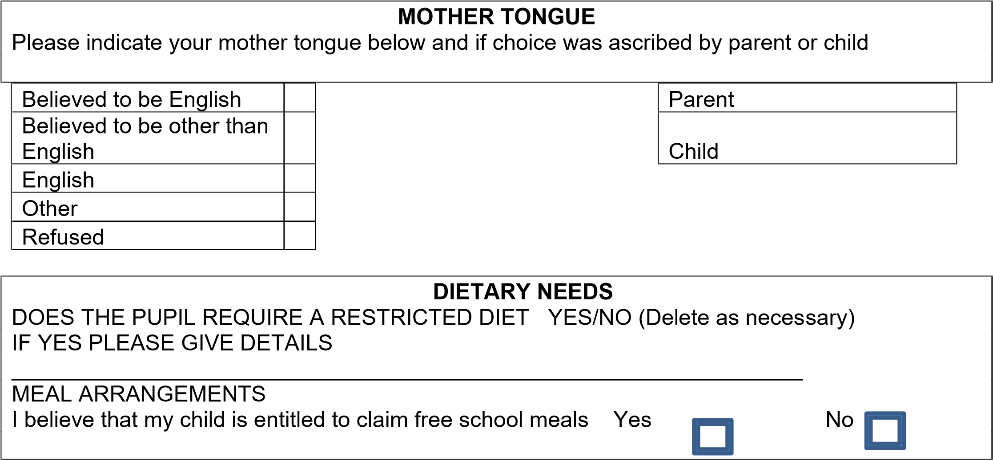

# MEDICAL DETAILS

MEDIAL PRACTICE ________________________________TEL NUMBER ________________

DOCTOR’S NAME

_________________________________________________________________________

MEDICAL CONDITIONS

____________________________________________________________________

____________________________________________________________________

Please indicate if your child has a current Individual Health Care Plan Yes / No

# TRAVEL ARRANGEMENTS

Please indicate your normal mode of travel to and from school. Please refer to the relevant guidance if necessary.

Bicycle / Train / Car or Van / Walk / Taxi / School Bus / Car Share / Public Bus Service / Other

# SERVICE CHILDREN IN EDUCATION

Please indicate below if a parent or parents are Service personnel serving in regular HM Forces Military units of all forces and exercising parental care and responsibility.

I / we are members of the Armed Forces

I / we are not members of the Armed Forces

# SCHOOL HISTORY

Please indicate the current / last school attended by the pupil ( INCLUDING OVERSEAS ) -

______________________________________________________________________________________

|  |  |  |
| --- | --- | --- |
| **ADDITIONAL EDUCATIONAL NEEDS**    Please give details of any additional educational needs of the pupil eg Impaired hearing, Dyslexia, gifted & talented, at their current school. | | |
|  | | |
|  | | |
| Is Your Child registered as a young carer **Yes**    **No** |  |  |
|  |

|  |  |  |  |  |  |  |  |  |  |  |  |  |  |  |  |  |  |  |  |  |  |  |  |  |  |  |  |
| --- | --- | --- | --- | --- | --- | --- | --- | --- | --- | --- | --- | --- | --- | --- | --- | --- | --- | --- | --- | --- | --- | --- | --- | --- | --- | --- | --- |
| **PASTORAL AND SAFEGUARDING INFORMATION**    Please let us know if your child is currently supported by any of the following plans or outside agencies.     |  |  |  | | --- | --- | --- | | **Agency or support plan:** | **Yes** | **No** | | Early Help record |  |  | | Team around the Child/Family |  |  | | Child in Need plan |  |  | | Child Protection plan |  |  | | TaMHS |  |  | | CaMHS |  |  | | Social worker |  |  | | Family Services |  |  |     Other (Please state) |

I confirm that I/we would like the pupil detailed on this form to be offered a place at The Deanery

Signed ______________________________ Print ________________________ Date

_________________

Signed ______________________________ Print ________________________ Date _________________

**Please turn over and complete the Parental Consents**

**Parent Consents / agreements – PLEASE CIRCLE**

**Use of pupil photograph on website / social media Y / N**

**I consent for my child to leave the school premises, independently in the event of an**

**emergency / school closure Y / N**

**I have read and understood the school behaviour policy Y /N**

**I consent medical treatment via a first aid trained member of staff for example an ice pack**

**Y /N**

**I consent for a biometric thumb print to be taken for the purpose of using the canteen**

**Y /N**

**I have read and understood the uniform policy**

**Y /N**

**I consent for DBS checked adult to be present on school trips**

**Y / N**

**I have read and understood the school attendance policy including understanding that holiday during term time will not be granted and may incur a local authority fine**

**Y / N**

**I will take time to read The Deanery policies** [**https://www.dcea.org.uk/policies/**](https://www.dcea.org.uk/policies/) **relating to the following:**

**Charging and remissions Student friendly safeguarding**

**Code of Conduct RSE & RSHE**

**Education Visits Anti bullying**

**ICT acceptable usage Equality**

**Intimate Care Lockdown**

**On line safety**

**Positive handling**

**Pupils mental health**

**Supporting pupils with medical conditions**

**Safeguarding & child protection**